### Design Document of User Interface

### Software used to implement the user interface

## Libraries used :

1. **Tkinter**

Tkinter is the most commonly used method for developing GUI. Python with Tkinter is the fastest and easiest way to create GUI applications.

Tkinter widgets used for developing GUI:

* Label
* Entry
* Canvas
* Option menu
* Frame
* Button

To create a tkinter app:

* Importing the module – tkinter
* Create the main window (container)
* Add any number of widgets to the main window

1. **Matplotlib**

* **Matplotlib** is a [plotting](https://en.wikipedia.org/wiki/Plotter) [library](https://en.wikipedia.org/wiki/Library_(computer_science)) for the [Python](https://en.wikipedia.org/wiki/Python_(programming_language)) programming language and its numerical mathematics extension [NumPy](https://en.wikipedia.org/wiki/NumPy" \o "NumPy).
* It is mainly used for plotting graph.

1. **Animation**

* Animations make even more sense when depicting time series data
* Matplotlib’s animation base class deals with the animation part.
* It provides a framework around which the animation functionality is built.
* [FuncAnimation](https://matplotlib.org/api/_as_gen/matplotlib.animation.FuncAnimation.html#matplotlib.animation.FuncAnimation) is the main object that makes an animation by repeatedly calling a function func.

### Anaconda



Anaconda is an open-source distribution of the Python and R programming languages for scientific computing, that aims to simplify package management and deployment. The distribution includes data-science packages suitable for Windows, Linux, and macOS.

### Visual Studio Code

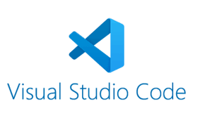

Visual Studio Code is a free source-code editor made by Microsoft for Windows, Linux and macOS. Features include support for debugging, syntax highlighting, intelligent code completion, snippets, code refactoring, and embedded Git.

### GUI for Configurator

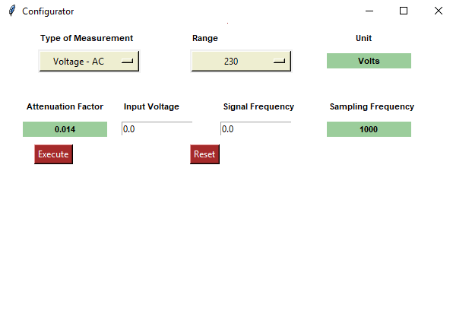

* The above is GUI for Configurator, which has

1. Option menu for selecting type of measurement and range.
2. Label for displaying the unit, attenuation factor and sampling frequency.
3. Entry for taking input of voltage and signal frequency from user.
4. Button for read data and plot the input signal.

* The input from the user will read from the Configurator GUI.
* That data will have sent to source.

### Input Signal

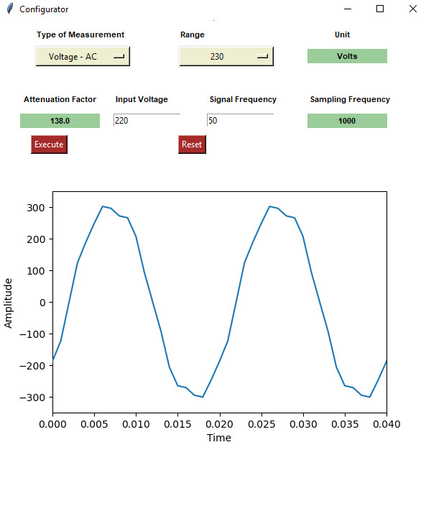

* The above GUI shows that the data from the user will take and the plot the input graph.

### GUI for Display

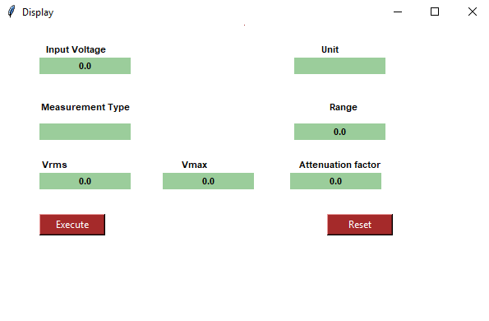

The above is GUI for Display, which has

* Label for displaying the input voltage, unit, measurement type, range and attenuation factor.
* If the measurement type is AC, the Vrms and Vmax value will be displayed in the GUI.
* If the measurement type is DC, only the Vavg value will be displayed in the GUI.
* Button to plot the output signal

### Output Signal

